Personal Locator Beacon
Technical Specifications

National Communications Commission
July 15,2020

*Should there be any discrepancy between the English and Chinese versions, the Chinese version shall prevail.

Personal Locator Beacon Technical Specifications
- Legal Source
The Specifications are enacted pursuant to Paragraph 1 of Article 44 of Telecommunications Management Act.
- Scope of Application
The Specifications are applicable to the type approval of personal locator beacon (PLB) with a master signal frequency of 406 MHz (406.0 MHz to 406.1 MHz) and auxiliary signal frequency of 121.5MHz (121.493925 MHz to 121.506075 MHz).
- Technical Standards
The Specifications stipulated in accordance with international technical standards, including Cospas-Sarsat C/S T.001, C/S T.007, C/S T.012 (hereinafter referred to as C/S T.001, C/S T.007 and C/S T.012) and RTCM Standard 11010.2.
- Terminology
4.1 Personal Locator Beacon (PLB):
refers to a device that can, when a person is placed on an emergency hold, instantly transmit 406 MHz emergency signals or 121.5 MHz auxiliary signals to the satellite to facilitate the search and rescue mission.
4.2 Cospas-Sarsat System:
refers to the all-weather auxiliary search and rescue (ASR) international satellite system that receives 406 MHz emergency signals and transmits the signals to the most suitable (nearest) Mission Control Center (MCC) to activate search and rescue missions.
4.3 Radio Technical Commission for Maritime Services (RTCM):
refers to an international non-profit scientific, professional and educational organization that stipulates radar system, personal radio beacon and related standards.
- Testing Items and Eligibility Criteria:
5.1 PLB on the 406 MHz frequency shall be inspected in accordance with Section 5.2, except for those that have received a Cospas-Sarsat type approval and attached related test report(s) or type approval certificate(s).
PLB on the 121.5 MHz frequency shall be inspected in accordance with Section 5.3, except for those that have attached related test report(s) issued by a foreign testing laboratory complying with RTCM standards.
5.2 Master Transmission Signals

5.2.1 Transmission Frequency Range: 406.0 MHz to 406.1 MHz.

5.2.2 Operating Temperature Range: is divided into Class 1(-40 ℃ to ＋55 ℃) and Class 2(-20 ℃ to ＋55 ℃).

5.2.3 Electrical and Functional Tests at Constant Temperature:
conduct the following tests at the lowest (T_{min}; Class 2: -20 ℃/Class 1: -40 ℃), maximum (T_{max}; 55 ℃) and ambient (T_{amb}) operating temperature 15 minutes after activating the PLB.
5.2.3.1 Transmitter Power Output
(1) Power output: 35 decibel-milliwatts (dBm) to 39 dBm.
(2) Power output rise time: < 5 milliseconds (ms).
(3) When the power output rises to 10% of the maximum power value, the power output of the previous 1 ms: < -10 dBm.
(4) Test method: in accordance with A.2.1 and A.3.2.2 (except A.3.2.2.3) of C/S T.007.
5.2.3.2 Digital Message
(1) Digital message structure and field: the encoding format shall comply with ANNEX A and B of C/S T.001.
(2) Test method: in accordance with A.2.1 and A.3.1.4 of C/S T.007.
5.2.3.3 Digital Message Generator
(1) Repetition period: shall comply with A.3.1.1 of C/S T.007.
Average: 48.5 seconds (s) to 51.5 s.
Minimum range: 47.5 s to 48.0 s
Maximum range: 52.0 s to 52.5 s.
Standard variability: 0.5 s to 2.0 s.
(2) bit rate: 396 bps to 404 bps.
(3) Message bit number and time length: short message: 112 bit, 435.6 ms to 444.4 ms; long message): 144 bit, 514.8 ms to 525.2 ms.
(4) Duration of unmodulated carrier: 158.4 ms to 161.6 ms.
(5) First burst delay: ≧47.5 s.
(6) Test method: in accordance with A.2.1, A.3.1, A.3.1.1, A.3.1.2 and A.3.1.3 of C/S T.007.
5.2.3.4 Modulation
(1) Coding method: biphase-L; modulation method: phase modulation.
(2) Modulation rise time: 50 microseconds (μs) to 250 μs.
(3) Modulation fall time: 50μs to 250 μs.
(4) Phase deviation: positive phase: +(1.0 to 1.2) rad; negative phase: -(1.0 to 1.2) rad.
(5) Modulation symmetry : ≦0.05.
(6) Test method: in accordance with A.2.1 and A.3.2.3 of C/S T.007.
5.2.3.5 Transmitted Frequency
(1) Transmission channel(s): shall comply with the channel(s) designated in Table H.2 of C/S T.012.
(2) Short-term stability: ≦2×10⁻⁹/100 ms.
(3) Medium-term stability: : ±1×10⁻⁹/minute (min).
(4) Medium-term residual frequency variation : ≦3×10⁻⁹.
(5) Test method: in accordance with A.2.1 and A.3.2.1 of C/S T.007
5.2.3.6 Spurious Emission
(1) Spectrum emission mask: shall comply with the spectrum standard values specified in Figure 1 (with the resolution bandwidth of100 Hz).
(2) Test method: in accordance with A.2.1 and A.3.2.2.4 of C/S T.007.
5.2.3.7 Voltage Standing Wave Ratio (VSWR)
(1) Transmission channel(s): shall comply with the channel(s) designated in Table H.2 of C/S T.012.
(2) Modulation rise time: 50μs to 250 μs.
(3) Modulation fall time: 50μs to 250 μs.
(4) Phase deviation: positive phase: +(1.0 to 1.2) rad; negative phase: -(1.0 to 1.2) rad.
(5) Modulation symmetry : ≦0.05.
(6) Digital message: the encoding format shall comply with ANNEX A and ANNEX B of C/S T.001.
(7) Test method: in accordance with A.2.1 and A.3.3 of C/S T.007.
5.2.3.8 Self-Test Mode and GNSS Self-Test Mode (if applicable)
(1) All test values shall comply with C/S T.001 4.5.4.
(2) Test method: in accordance with A.2.1 and A.3.6 of C/S T.007.

5.2.4 Thermal Shock Test: place PLB in a thermal shock of 30°C within the specified operating temperature range; the following tests shall be conducted 15 minutes after activating the beacon.
5.2.4.1 Transmitter Power Output
(1) Power output: 35 dBm to 39 dBm.
(2) Test method: in accordance with A.2.2 and A.3.2.2.1 of C/S T.007.
5.2.4.2 Digital Message
(1) Digital message structure and field: the encoding format shall comply with C/S T.001 ANNEX A and ANNEX B.
(2) Test method: in accordance with A.2.2 and A.3.1.4 of C/S T.007.
5.2.4.3 Transmitted Frequency
(1) Transmission channel(s): shall comply with the channel(s) designated in Table H.2 of C/S T.012.
(2) Short-term stability: ≦2×10⁻⁹/100 ms.
(3) Medium-term stability: ±2×10⁻⁹/min.
(4) Medium-term residual frequency variation: ≦3×10⁻⁹.
(5) Test method: in accordance with A.2.2 and A.3.2.1 of C/S T.007.

5.2.5 Operating Lifetime at Minimum Temperature: Class 1 and Class 2 PLB shall be operated at the lowest temperatures of -40 ℃ and -20 ℃ for 24 hours.
5.2.5.1 Transmitter Power Output
(1) Power output: 35 dBm to 39 dBm.
(2) Test method: in accordance with A.2.3 and A.3.2.2.1 of C/S T.007.
5.2.5.2 Digital Message
(1) Digital message structure and field: the encoding format shall comply with C/S T.001 ANNEX A and ANNEX B.
(2) Test method: in accordance with A.2.3、A.3.1.4 C/S T.007.
5.2.5.3 Transmitted Frequency
(1) Transmission channel(s): shall comply with the channel(s) designated in Table H.2 of C/S T.012.
(2) Short-term stability: ≦2×10⁻⁹/100 ms.
(3) Medium-term stability: : ±1×10⁻⁹/min.
(4) Medium-term residual frequency variation: ≦3×10⁻⁹.
(5) Test method: in accordance with A.2.3 and A.3.2.1 of C/S T.007.

5.2.6 Frequency Stability Test with Temperature Gradient:
The PLB under test, while turned off, is to stabilize for 2 hours at the minimum operating temperature T_{min}(Class 2：-20 ℃/Class 1：-40 ℃) and then turned on to run the test 15 minutes later. After an hour of placement, increase the temperature by adding +5 ℃ every hour until the maximum temperature T_{max}(55 ℃) is reached. Run the maximum temperature test for 15 min and stabilize the PLB for 2 hours. Next, decrease the temperature by dropping -5 ℃ every hour until the minimum temperature T_{min}(Class 2: -20 ℃/Class 1: -40 ℃) is reached. Run the test for minimum temperature test for 15 min and stabilize the PLB for 2 hours (as illustrated in Figure 2). The PLB shall be operated with the following functions.
5.2.6.1 Transmitter Power Output
(1) Power output: 35 dBm to 39 dBm.
(2) Test method: in accordance with A.2.4 and A.3.2.2.1 of C/S T.007.
5.2.6.2 Digital Message
(1) Digital message structure and field: the encoding format shall comply with ANNEX A and ANNEX B of C/S T.001.
(2) Test method: in accordance with A.2.4 and A.3.1.4 of C/S T.007.
5.2.6.3 Transmitted Frequency
(1) Transmission channel(s): shall comply with the channel(s) designated in Table H.2 of C/S T.012.
(2) Short-term stability: ≦2×10⁻⁹/100 ms.
(3) Medium-term stability: shall comply with Table A.1 of C/S T.007.
(4) Medium-term residual frequency variation: shall comply with Table A.1 of C/S T.007.
(5) Test method: in accordance with A.2.4 and A.3.2.1 of C/S T.007.

5.2.7 Beacon Antenna Test: The beacon antenna test shall be performed at the ambient temperature of the test facility and a correction factor shall be applied to the data to calculate the radiated power at minimum temperature at the end of the operating lifetime of PLB. The antenna specifications and related data shall be specified in the antenna test report.
5.2.7.1 Polarization
(1) Polarization method: linear or RHCP.
(2) Test method: in accordance with A.2.6, A.3.2.2.3 and Annex B of C/S T.007.
5.2.7.2 VSWR
(1) VSWR: ≦1.5.
(2) Test method: in accordance with A.2.6, A.3.2.2.3 and Annex B of C/S T.007.
5.2.7.3 Effective Isotropic Radiated Power (EIRP)
(1) In accordance with the EIRP under the configurations of Figure B.2 or B.4 of C/S T.007: 32 dBm to 43 dBm.
(2) In accordance with the EIRP under the configurations of Figure B.5 of C/S T.007: 30 dBm to 43 dBm.
(3) Test method: in accordance with A.2.6, A.3.2.2.3 and Annex B of C/S T.007.

5.2.8 Navigation System Test: PLBs with the navigation system shall meet the requirements of this Section. Unless otherwise specified in 5.2.8.8, the navigation input system shall be operated during the test and be ensured that it does not affect the 406 MHz signals.
5.2.8.1 Position Data Default Values
(1) Position data default value: shall comply with A.3.2 of C/S T.001.
(2) Test method: in accordance with A.2.7 and A.3.8.1 of C/S T.007.
5.2.8.2 Position Acquisition Time
(1) Position acquisition time of PLB with a built-in navigation system: < 10 min.
(2) Position acquisition time of PLB with an external navigation system: < 1 min.
(3) Test method: in accordance with A.2.7 and A.3.8.2 of C/S T.007.
5.2.8.3 Position Accuracy
(1) Position accuracy: when transmitting a message in accordance with National Location Protocols and Standard Location Protocols, the position error value shall be less than 500 meters (m); when sending a message in accordance with User-Location Protocol, the position error value shall be less than 5.25 kilometers (km).
(2) Test method: in accordance with A.2.7 and A.3.8.2 of C/S T.007.
5.2.8.4 Encoded Position Data Update Interval
(1) Encoded position data update interval: > 5 min.
(2) Test method: in accordance with A.2.7 and A.3.8.3 of C/S T.007.
5.2.8.5 Position Clearance after Deactivation
(1) Position clearance after deactivation of PLB: Confirm that the position data has been removed and the encoded position data in the message is the default value.
(2) Test method: in accordance with A.2.7 and A.3.8.4 of C/S T.007.
5.2.8.6 Position Data Input Update Interval
(1) Position data input update interval: < 20 min.
(2) Position data input clearance interval: 20 min to 30 min.
(3) Test method: in accordance with A.2.7 and A.3.8.5 of C/S T.007.
5.2.8.7 Last Valid Position
(1) Retained last valid position after the removal of last valid position and no more new position data input: 240±5 min.
(2) Default position data transmitted by the PLB after the test specified in 5.2.8.7(1): confirm that the final valid position data has been removed and the encoded position data in the message is the default value.
(3) Test method: in accordance with A.2.7 and A.3.8.6 of C/S T.007.
5.2.8.8 Position Data Encoding
(1) The accuracy of BCH code of position data: shall comply with Annex B of C/S T.001.
(2) Test method: in accordance with A.2.7, A.3.8.7 and Annex D of C/S T.007.

5.2.9 Beacon Coding Software Test: The digital message for each beacon message protocol supported by the beacon shall be verified at ambient temperature. This test shall evaluate both the real and self-test modes for each beacon message protocol. For the purpose of validating specific beacon message protocols, the PLB shall be programmed in accordance with the guidance provided at Annex C of C/S T.007. For location protocols, verification of 2 messages with encoded position data is required. Among them, he second message shall be provided with encoded position at least 500 m from the first position for the National Location Protocols and Standard Location Protocols; or 10 km for the User-Location protocol. The verification of the digital message does not require a change of location of the PLB.
5.2.9.1 The integrity of every message protocol in practice: shall comply with Annex C of C/S T.007.
5.2.9.2 The integrity of every message protocol in the self-test mode: shall comply with Annex C of C/S T.007.
5.2.9.3 Test method: in accordance with A.2.8, A.3.1.4 and Annex C of C/S T.007.

5.2.10 Testing Beacons Designed to Transmit Short or Long Format Messages:
5.2.10.1 PLB that can transmit short or long message: shall run all the tests specified in Section 5.2 using the long message.
5.2.10.2 PLB that transmits short message: shall run the test items specified in Sections 5.2.3.2, 5.2.3.3, 5.2.3.4, 5.2.3.8 and 5.2.9 at the ambient temperature.
5.2.10.3 The test methods shall comply with A.2.1, A.2.8, A.2.9, A.3.1.4 and Annex C of C/S T.007.
5.3 The 121.5 MHz Auxiliary Signal

5.3.1 Transmission Frequency Range: 121.493925 MHz to 121.506075 MHz.

5.3.2 Peak Effective Isotropic Radiated Power (PEIRP): 14 dBm to 20 dBm.

5.3.3 Duty Cycle: 100%. However, when transmitting the 406 MHz master signal, the 121.5 MHz auxiliary signal can be interrupted for maximum 2 s.

5.3.4 The Modulation method of Transmission and Morse Code Signals: amplitude-modulated (AM) signals (3K20A3X) and p-format Morse code (2K00A2A) as illustrated in Figure 3.

5.3.5 Modulation Duty Cycle: 33% to 55%.

5.3.6 Modulation Factor: 0.85 to 1.0.

5.3.7 Sweep Repetition Rate: 2 Hz to 4 Hz.

5.3.8 Spurious Emission: shall comply with the spectrum standard values specified in Figure 4 (with the resolution bandwidth of100 Hz).

5.3.9 Antenna Pattern: omni directional in horizontal, ±3 dB.

5.3.10 Antenna Polarization: vertical polarization.

5.3.11 Minimum Operating Life Time: 24 hours (within PLB’s operating temperature range.

5.3.12 Test method: in accordance with A.16 of RTCM Standard 11010.2.

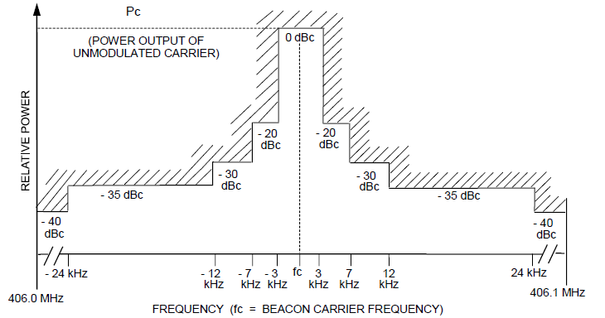
Figure 1 Standard values of spectrum emission mask

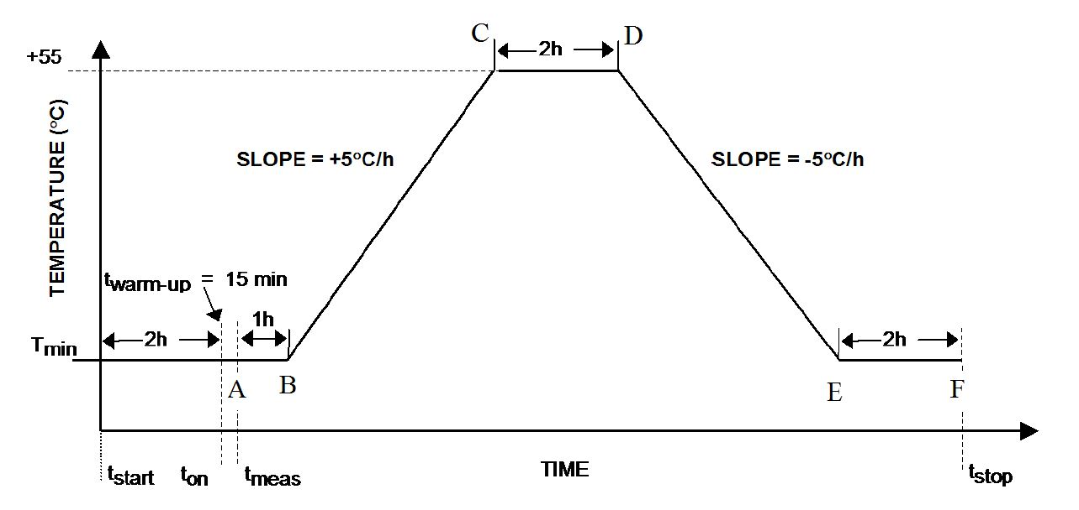
Figure 2 Temperature gradient test

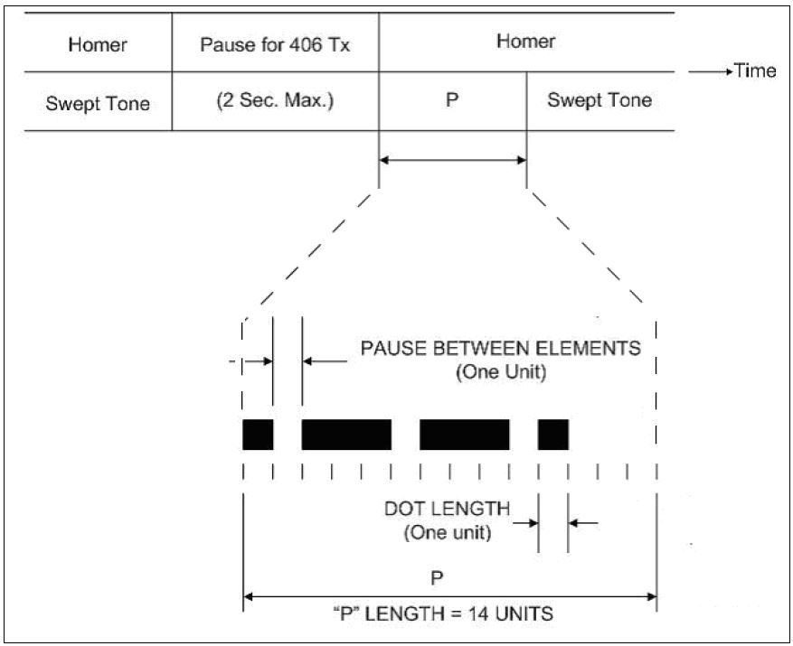
Figure 3 The modulation of transmission and Morse code signals
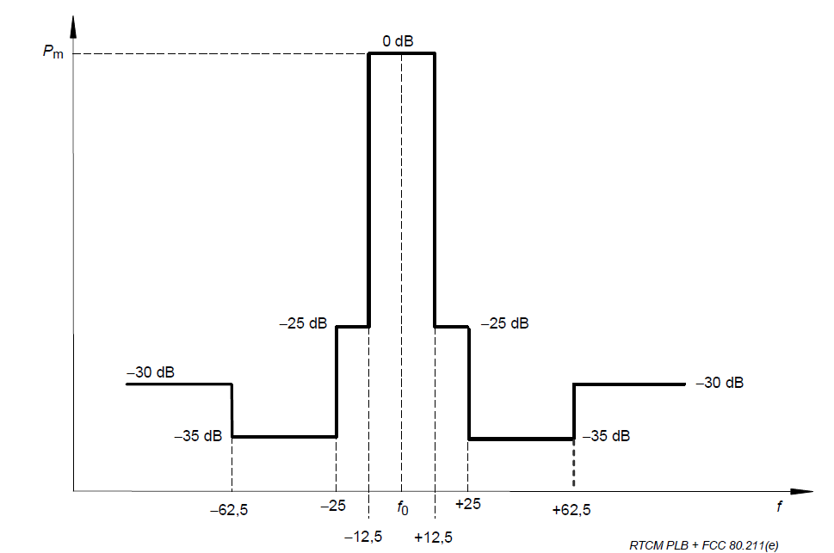
Figure 4 Standard values of spurious emission spectrum

