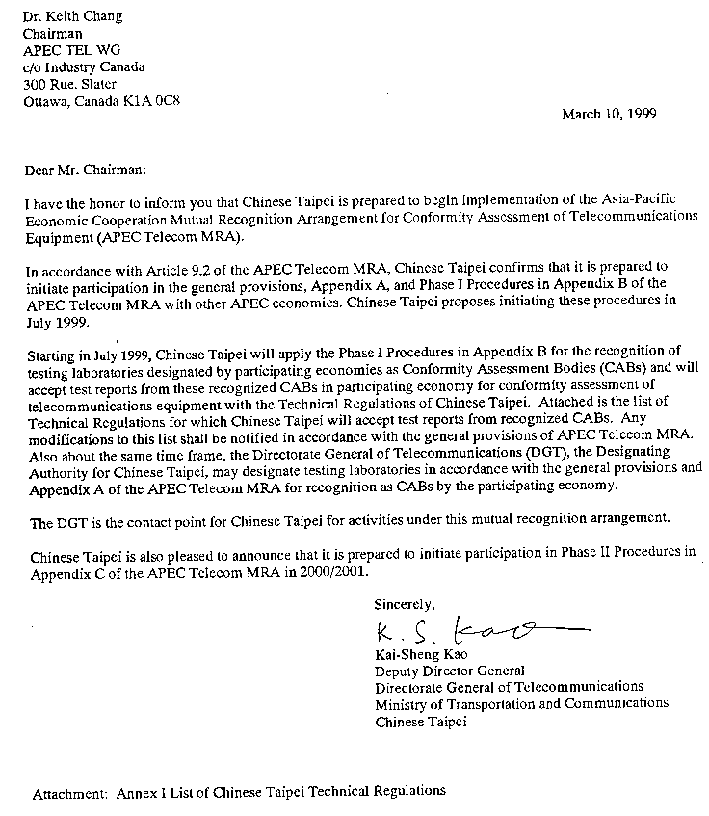

LIST OF TECHNICAL REGULATIONS
FOR [Chinese Taipei]

PHASE I

The Technical Regulations for which [Chinese Taipei] will accept test reports from recognized Conformity Assessment Bodies designated by other Parties are:

NO. | Technical Regulations
 | 1996 Telecommunications Act
TTE001-0 | Technical Specifications and Approval Inspection Regulations of Telecommunications Terminal Equipment
LG1000-0 | The Assessment and Approval Guidelines for Telecommunications Terminal Equipment Testing Laboratories
LG1001-0 | Assessment Manual for Testing Laboratories
LG1002-0 | The Assessment and Approval Guidelines for Testing Laboratory Accreditation Bodies
LG1003-0 | Assessment Manual for Testing Laboratory Accreditation Bodies
IG0005-11 | Subscriber Self-provided Equipment Type Approval Guidelines
IL0003-2 | In-House Wiring Apparatus Type Approval Guidelines
IE0005-4 | Private Branch Exchange and KTS Type Approval Guidelines
ID0001-4 | Data Equipment Type Approval Guidelines
ID0002-1 | DS1 Equipment Type Approval Guidelines
ID6100-2 | ISDN CPE Type Approval Guidelines
IT0002-2 | CT-2 Wireless Private Branch Exchange System Equipment Type Approval Guidelines
IS2020-4 | AMPS Mobile Station Type Approval Guidelines
IS2014-4 | GSM Mobile Station Type Approval Guidelines
IS2017-0 | DCS-1800 Mobile Station Type Approval Guidelines
IS4450-3 | 160MHz - 1200 bps Radio Paging Receiver with Numeric Display Type Approval Guidelines
IS4451-3 | 280MHz - 1200 bps Radio Paging Receiver with Numeric Display Type Approval Guidelines
IS4462-3 | Radio Paging Receiver with Chinese Character Display Equipment Type Approval Guidelines
IS2018-0 | 284.5MHz - 285.5MHz Radio Paging Receiver Type Approval Guidelines
IS2016-0 | Mobile Data Terminal Equipment Type Approval Guidelines
IS2015-0 | Trunked Radio Mobile Station Type Approval Guidelines
IS2019-0 | 1.6/2.4 GHz Satellite Personal Communications Networks (S-PCN) Mobile Earth Stations (MESs) Technical Requirements and Type Approval Guidelines
IS2030-3 | Mobile Telecommunications Base Station RF Equipment Technical Specifications and Approval Inspection Guidelines
 | Regulations on Inspection and Certification of Controlled Telecommunications Equipment
 | Technical Regulations for Low-power Radio-frequency Devices
 | Type Approval Guidelines on Low-power Radio Frequency Equipment
 | Amateur Radio Technical Guidelines

